Article

Microgrid Energy Management System of Marmara University RTE Campus

Şakir Bingöl1, Ali Temir 2, Sena Gül Tunçbilek 3, Yusuf Bedir 4

|  |
| --- |
| **Citation:** To be added by editorial staff during production.  Academic Editor: Firstname Lastname  Received: date  Accepted: date  Published: date  **Publisher’s Note:** MDPI stays neutral with regard to jurisdictional claims in published maps and institutional affiliations.  Picture 4  **Copyright:** © 2022 by the authors. Submitted for possible open access publication under the terms and conditions of the Creative Commons Attribution (CC BY) license (https://creativecommons.org/licenses/by/4.0/). |

1Affiliation 1; sakir.bingol@marmara.edu.tr

2Affiliation 2; alitemir@marun.edu.tr

3Affiliation 3; sena.gul@marun.edu.tr

4Affiliation 4; yusufbedir@marun.edu.tr

**Abstract: Today, with the increasing world population, the amount of energy used and the need for energy are constantly increasing. However, limited resources to meet this energy demand encourage people to look for different ways to use energy more efficiently. For this reason, people are working in different areas on how to use energy efficiently. In this study, renewable energy sources were used to create an energy management system on a microgrid and to achieve cost optimization with this system. Marmara University Engineering Faculty was chosen as the case study. Solar and wind energy was converted into electrical energy by adding solar panels and wind turbines to the micro grid circuit of the faculty created in MATLAB/Simulink. The converted energy is directed to the building and the grid with the battery modelling created in the simulation. As a result of this, cost optimization has been achieved to a great extent, and the efficiency of renewable energy use has been revealed at the same time.**

**Keywords:** battery optimization; microgrids; energy management; energy storage; renewable energy; EMS.

1. Introduction

Global energy demand is increasing day by day. According to BP (British Petroleum), use of energy worldwide has grew by factor of about one and a half times since 1990, to 13 billion tons of oil equivalent (in year 2014), up from 8 billion (in year 1990). Consequently, the amount of CO2 emissions grew by factor of about one and a half times, from 23 billion tons to 35 billion tons [1]. Since this energy need is largely provided by the use of fossil fuels, there is concern about the future of the world [2]. Therefore, the demand for renewable energy sources (RES) is increasing in order to reduce energy costs and prevent pollution in settlements [3]. Renewable resources are constantly renewed as they come from nature. Thermal and photovoltaic (PV) energy can be produced from the sun. Wind and hydro Energy are examples of non-sun-produced energy. Energies such as geothermal and bioenergy can come from other environmental processes and world’s behavior [4]. Globally, the usage of renewable energy is rising substantially. Consumption grew to 18% in 2015 from a value of roughly 17% in 2010. Only 8% of traditional biomass and 10% of contemporary RES, such as solar and wind, were represented in the 18% [5]. Although the contribution of these energy sources to energy production is quite high, they must be created using very efficient methods as they create power fluctuations in energy production.

A group of distributed energy resources (DER),includes microgrids (MG), RES, energy storage systems (ESS) and locally operated loads as a single controllable entity. MG is defined as both low and medium voltage, with an operating range typically between 400V and 69kV. Also available in various sizes. These are large, complex grids up to 10 MW, with multiple power and storage units serving multiple loads. MGs, on the other hand, are small and simple systems in the hundreds of kW range, which may only power a small number of customers [6]. State-of-the-art technologies such as RES, natural gas-fired turbines, fuel cells (FC) and small modular nuclear reactors can all power MG once they become economically viable. Critical facilities can be powered after weather or security-related outages affect large systems. In addition, MG also serves as the primary power source for neighborhoods and hospitals. Many cities are now interested in systems that can better integrate generated resources and loads, serve multiple users, and replace single-user and campus MGs serving an industrial site or military garrison [7]. The MG industry is estimated to reach $7.76 billion by 2021. The market is expected to grow from $8.74 billion to $23.49 billion from 2022 to 2029, at a CAGR of 15.2%. The COVID-19 outbreak was an unprecedented shock, with market demand below expectations in all regions compared to pre-pandemic levels. This data shows that the global market in 2020 fell by 6.29% compared to his 2019[8].

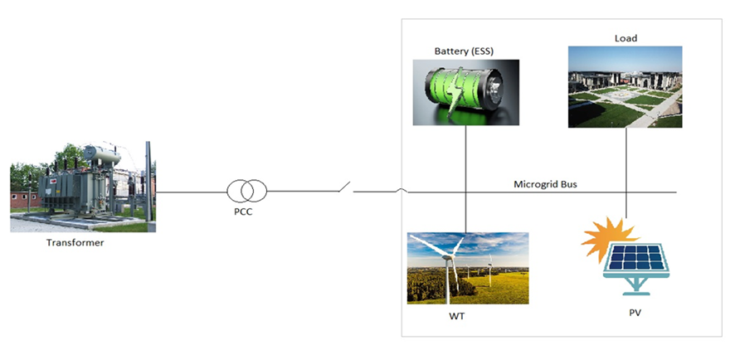

Figure 1.1 Representative diagram of the microgrid aimed in the study.

MGs are now being used more extensively as a device for integrating DERs. In order to create a hybrid system that can meet a particular load requirement, RESs are typically combined with energy storage technologies. When the systems used in different studies are examined, the power obtained as a result of the use of wind turbine together with PV is more reliable. However, in addition to this advantage, this combination also has a disadvantage that it is largely dependent on climatic factors. As a backup, ESS can be coupled to address this issue. It is important to use optimal system sizing in addition to the use of energy management systems (EMS), as each component added to the system will increase the cost as well as affect the system reliability [9]. Rule-Based EMS (RBEMS) and Optimization-based EMS are the two types of EMSs (OBEMS). OBEMS minimizes the cost to the business along with technical constraints by implementing an optimization-based unit engagement model. On the other hand, the more complex RBEMS allows the decision to transmit or store the energy produced from renewable sources to the MG by applying predefined logical rules. [10].

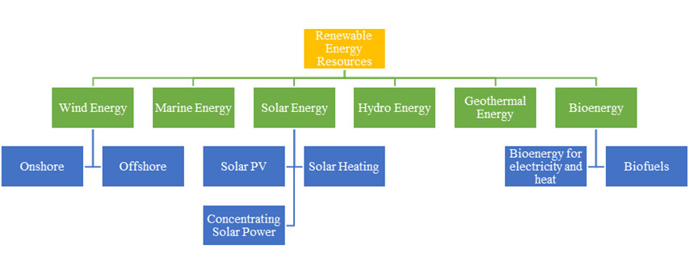

Figure 1.2 Schematic representation of renewable energy resources.

In this study, Marmara University Faculty of Engineering was chosen as the microgrid system application area. Renewable energy sources PV and WT energy sources were added to the circuit diagram created using MATLAB/Simulink. It is aimed to achieve cost optimization with the energies coming from these sources and it is aimed to make a battery modeling in line with this purpose. As a result of the studies on the simulation, a successful cost optimization has been obtained.

2. State of Art

A substantial amount of literature was analyzed before the EMS design in this project was carried out. The areas and goals of these investigations were highlighted. In one of these studies, Diesel generators (DG), FC, WTs, PV panels, and ESS are a few of the micro-sources that make up the MG [11]. In controlling RES, ESSs are crucial. Power electronics and ESSs work together to stabilize intermittent power generation, resulting in enhanced power quality and efficient demand response (DR) [12].

A consistent and reliable power supply cannot be provided by a single RES due to the fact that the fluctuation of various RESs frequently results from complimentary meteorological circumstances. Utilizing hybrid RES systems, which help deliver continuous power supply and reduce the negative effects of RES variability through the integration of several RESs, is one way to solve this problem. By combining several RESs, including PV, WT, biomass, hydropower, etc., hybrid RES systems can be created [13]. In order to use the ESS, PV, and WT components that will used in the EMS design in the most effective way, the appropriate technique should be chosen [14].

Numerous methods used as a consequence of literature study were examined. In one of them is, in Erenoğlu, Ayşe Kübra, et al. [15], A framework for scenario-based stochastic optimization is described. Mathematical model including Mixed integer linear programming (MILP) achieved global optimality. Additionally, a Demand Response (DR) software based on Direct Load Control (DLC) was employed to reduce losses in the MG. The potential of thermostatically controllable appliances (TCA) has been exploited to save energy. The study has revealed that, in relation to loss mitigation and ambiguity resolution in MG operation, the stochastic strategy performs better than the deterministic approach.

In [16], multi-objective particle swarm optimization (MOPSO) method was applied to actualize the most efficient level of energy transport for mg operating in the presence of PV and WT. The results of this method were compared with the results of the Genetic Algorithm (GA) method and it was concluded that MOPSO used ESS more efficiently than GA. In another study [17], 3 model-based Newton-Phaselet load identification system, Long Short-Term Memory (LTSM ) prediction model and GA optimization were used for Home Energy Management System (HEMS). This system, which estimates power consumption, aims to minimize the cost by optimizing the usage.

In order to increase the availability of electric power while taking developing nations like Ecuador into account, a study has developed an EMS architecture based on fuzzy logic control (FLC) for isolated MGs. Using the meta-heuristic algorithms Cuckoo Search (CS) and Particle Swarm Optimization (PSO), the membership functions of FLC employed in the study were modified and compared. The results showed that the PSO-based EMS performed better, but varied results from the two algorithms demonstrated that it is not feasible to validate a singular global solution to reduce the cost function of employing fuzzy logic controller [18].

During a study to increase system reliability in 2021, a control approach was introduced that allows hybrid DERs to be integrated into the DC MG system. In the study, the performance of PV/FC/BESS was evaluated by using an adaptive neuro-fuzzy inference system (ANFIS) based on teaching learning-based optimization (TLBO) in the MG system and it was found that it provides superior enrichment than other existing approaches [19]. At a conference published the same year, Reinforcement learning algorithms were utilized to create and build an EMS for various MG configurations [20]. For this, different advanced technology Deep Reinforced Learning (DRL) algorithms were used, the energy management problem was depicted as a Markov decision process, results close to an ideal operation were obtained with a trained DRL EMS representative and some simple EMS applications were produced.

In [21], an architecture consisting of three sub-headings as load identification, forecasting and optimization was established in a smart MG system that includes automated HEMSs. Thanks to this system, maximum comfort and minimum energy consumption are offered to the user. In another study [22], using real 24-hour load variation data captured in Perlis, Malaysia, a five MG system was modeled and simulated under various load conditions. With the Lightning Search Algorithm (LSA) used in the study, 62.5% cost savings compared to GO optimization and a 61.98% reduction in CO2 emissions compared to GO optimization based on the backtracking search algorithm were achieved. To assure the energy stability of a MG made up of batteries and RES, the EMS described in Calpbinici, Ayberk, et al. [23] was created. According to the operational mode, this specially created EMS controls how the MG operates. The major goals are to continuously flow loads to specific loads and to maximize source efficiency. The EMS in this investigation has three different operating modes. These are battery charging mode, full load mode, and island mode. The outcomes of the simulation demonstrate that each operating mode's energy efficiency is adequate.

In the study [24]’ s goals are to demonstrate the necessity for DC MGs powered by RES and to spark ideas for how these MGs might be improved when used with EMS. The permanent magnet synchronous generator has been employed as a generator source in the MG because it has several advantages over other sources in many ways. The EMS that was created for WTG is field-oriented. It includes algorithms like charge-discharge, MPPT, and control algorithms. The study suggests an EMS-optimized DC MG that is based on RES.

The topic of research and development into energy management and optimization in the MG system is one that never stops. The MG improves efficiency and guarantees that demand is always satisfied through distributed generation of energy sources, working in tandem with an EMS. Such a system has relatively high running expenses, which will be reduced by optimization. In Nesihath, M. K., et al. [25], the optimization types "Particle Swarm Optimization" and "Honey Badger Algorithm" are employed. Both optimization methods demonstrate the best possible usage of solar panels and WTs as RES. DG utilization is minimized in both methods. The honey badger algorithm is suggested as a remedy because, given the price of the MG, it yields encouraging results.

In [26], discusses the power management in DC MG systems, which are made up of composite ESS, solar energy systems, and wind energy conversion systems. To get the most energy possible from each source, both are used in maximum power point tracking mode. This article develops a power management algorithm and implements Solar and Wind MPPT techniques. Two RES are used as a remedy to operate in MPPT mode for optimal effectiveness.

In addition to these EMSs, there are EMSs created for college campuses around the globe. For instance, in [27], EMS design for MG encompassing PV, WT, and ESS has been realized for Nanjing University in China utilizing the interval optimization method. With this layout, the goal is to maximize profit. Besides this study, Fast Fourier Transform (FFT) algorithm technique was applied for MG at McNeese University in the USA. In another study [28], which used 15 kW PV, it was aimed to control the water flow to the generator. In addition, energy savings were achieved with preventive maintenance. Also in [29], Energy production efficiency was achieved with the GA technique by using ESS, RES and generators at Eindhoven University in the Netherlands. Moreover, in Guangdong University of Technology [30], NSGA-2 (Non-dominated Sorting Genetic Algorithm-2) was employed to maximize PV consumption and reduce operational costs using BESS and PV components.

3. Model and Application

A microgrid is being created for our campus as part of this project and there are many things to consider. One of them is the number of solar and wind energy generators required to meet our energy needs. What would be the capacity of the battery if it was chosen to store the energy produced? is another important question. A lot of data is already available. It is important to maximize both the income to be obtained from the energy that the microgrid will produce using this data and the installation costs. After all, investment is being made, so we must be aware of how much the project will benefit. Such calculations will be included in this section and question marks will be removed.

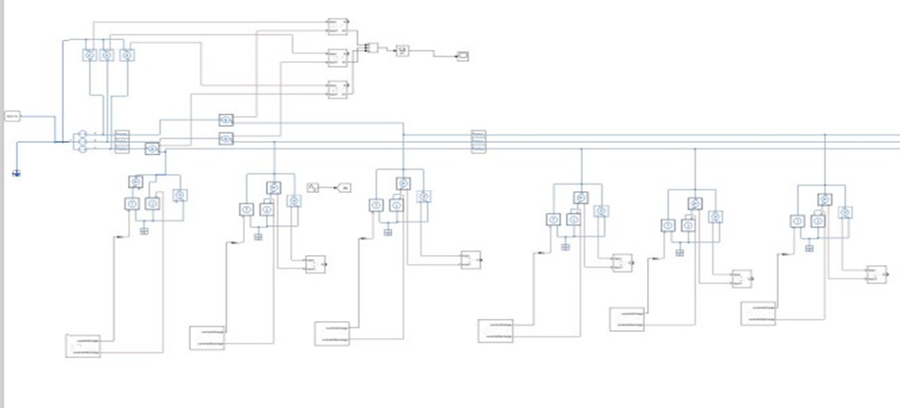

Figure 3.1 A section from the created Simulink circuit.

The parameters have been designed with this purpose in mind. The main objectives of this study are to identify the least amount of energy sources and to optimize the studied cases. Below are the formulas we will use for wind turbines, solar panels, diesel generators and the grid. A line can be drawn in the grid-microgrid connection using the optimization resulting from cost calculations using formulas.

The formulas used can be explained as follows. Installation cost, maintenance cost and operating cost in photovoltaic panel is calculated for 1 panel 1. In addition, since it is known how much energy the used panel will produce, a price comes out when it is multiplied by the 1 kW electricity value in Turkey. When the total cost is subtracted from this price, the profit value will be reached. Besides these calculations, there are cost and energy calculations.

The model works as follows: There is a micro grid and this micro grid is based on renewable energy. Solar panels and wind turbines produce electricity throughout the day and this energy is used for the campus. Noon hours for the solar panel and windy hours for the wind turbine are the times when the most energy can be produced. The estimated energy produced during these hours will meet the planned energy consumption. Since the demanded energy cannot be met outside these hours, the diesel generator will step in and support the micro-grid in terms of energy. Since the main grid will not be needed, the established microgrid will be a self-sufficient successful project.

3.1. Photovoltaic Model

The charging and discharging of the battery in the Simulink are mathematically formulated in the following equations.

$C_{pvct}=N_{pv}×C_{pvi}$ (1)

$C_{pvmt}=N_{pv}×C_{pvm}$ (2)

$C_{pvot}=N_{pv}×C_{pvo}$ (3)

${C_{pvt}=C}_{pvct}+C_{pvmt}+C_{pvot}$ (4)

$E_{pv}=N_{pv}×P_{pv}×T_{pv}×D_{pv}$ (5)

${{Profit}_{pvt}=E_{pv} ×{Price}_{pvh} - C}_{pvt}$ (6)

3.1.2.Wind Turbine Model

$C_{wtct}=N_{wt}×C_{wti}$ (7)

$C_{wtct}=N_{wt}×C_{wti}$ (8)

$C_{wtot}=N_{wt}×C_{wto}$ (9)

$C_{wtt} =C_{wtct} + C_{wtmt}+C_{wtot}$ (10)

$P_{wt}=A_{d}×W_{s}× {SA}_{wt}$ (11)

${Profit}_{wtt}=P_{wt}×{Price}_{wth}-{ C}_{wtt}$ (12)

3.2. Grid model $E_{g}=E_{md}-\left(E_{pv}\right)$  
   
 (13)

$C_{gt}=C_{kwh}×E_{g}$ (14)

The model works as follows: There is a microgrid and this micro grid is based on renewable energy. Solar panels produce electricity throughout the day and this energy is used for the campus. Noon hours for the solar panel when the most energy can be produced. The estimated energy produced during these hours will meet the planned energy consumption. Since the main grid will not be needed, the established microgrid will be a self-sufficient successful project.

3.2. Battery Model

In the battery management system developed for RTE campus Engineering Faculties, it is aimed to obtain maximum profit in 1 day (24 hours) from the energies produced from solar panels and wind turbines. Lion batteries are preferred because they are used for energy storage systems due to their high power, energy density and efficiency. The capacity of 5 selected batteries suitable for buildings is 1000kwh. Since the battery cannot have 0 value in the first-time interval, the energy value was determined as 500kwh. Thus, the initial charge rate of the Battery is 50 percent. The amount of energy to be stored in the battery and the charge rate will change according to the amount of energy coming or going from the battery after this time. As a result of researching in which situations the battery will be charged and discharged, an algorithm with high efficiency was used. The algorithm of the battery is as follows.

1. The powers from the wind turbine and pv panels are summed and this value is compared with the power values of the building.

2. If the generated power (pv and wind) is greater than the consumed power and the battery charge state is less than 95 percent, the battery switches to the charge state. If the generated power is less than the consumed power and the battery charge state is greater than 15, the battery switches to the discharge state. If both conditions are not present, the battery will not be charged or discharged.

3. The amount of energy and charge rate in the battery are updated according to the charge or discharge status of the battery.

*function [charge,discharge] = fcn(pvandwind,load,batterycharge)*

*if (pvandwind-load)>0 && (batterycharge<95)*

*charge=pvandwind-load;*

*discharge=0;*

*elseif (batterycharge>15) && (pvandwind-load)<=0*

*charge=0;*

*discharge=load-pvandwind;*

*else*

*charge=0;*

*discharge=0;*

*end*

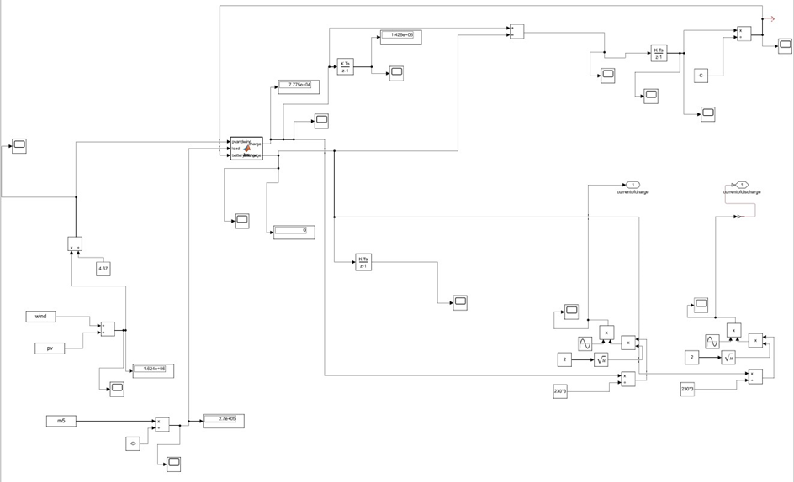

Figure 3.2 Battery model designed in Simulink.

4. Results and Discussion

In this section, the simulation results of the cost-optimized model developed for the Marmara Campus are presented. There are the 24-hour state of battery charge of the buildings.

ekran görüntüsü, kare, dikdörtgen içeren bir resim

Açıklama otomatik olarak oluşturuldu

Figure 4.1 Battery SoC for M5 building.

The state of charge of the batteries in the developed model starts from 50 percent and varies continuously between 15 and 95. Although 4 out of 5 batteries in the faculty did not generate energy from the pv panels at night, they were charged until the morning hours. The reason for this is that the power demanded in the buildings is not high at night and the efficiency of the wind turbines. Thanks to the fact that 4 out of 5 batteries are charged at night, the power demanded in the buildings during the daytime is supply from the energy stored in the battery. From morning hours to evening hours, the batteries switched to discharge mode in order to allocate the high-power demand in the buildings due to the insufficient energy produced from the wind and panels. After the evening hours, the batteries mostly remained stable at their charge levels or low charge and discharge fluctuations occurred. Only the battery of the M5 building has passed its recharge state from the evening hours. This is because the requested power of the M5 building is low.

The state of charge of the batteries in the developed model reached high and low levels during the day, resulting in a high efficiency of use of renewable energies. The state of charge of the batteries does not exceed 82 percent. The simulation results obtained include 24-hour data. If it is thought that the simulation is applied for long days, reaching a very high charge rate of the battery from the 1st day will not produce balanced results.

Tablo 4.1 Battery SoC Calculation for M5 building.

|  |  |  |  |  |  |
| --- | --- | --- | --- | --- | --- |
| Time | Building Consumption (W) | PV (W) | WT (W) | Charge (W) | Discharge(W) |
| 1 | 85000 | 0 | 141399 | 56399 | 0 |
| 2 | 90000 | 0 | 136902 | 46902 | 0 |
| 3 | 75000 | 0 | 135189 | 60189 | 0 |
| 4 | 95000 | 0 | 138829,3333 | 43829,33333 | 0 |
| 5 | 105000 | 0 | 143183,3333 | 38183,33333 | 0 |
| 6 | 135000 | 3966,666667 | 147822,6667 | 16789,33333 | 0 |
| 7 | 150000 | 20852 | 144468 | 15320 | 0 |
| 8 | 205000 | 40092 | 141613 | 0 | 23294,66667 |
| 9 | 215000 | 34216 | 151034,6667 | 0 | 29749 |
| 10 | 225000 | 23900 | 156388 | 0 | 44711,66667 |
| 11 | 230000 | 18914,66667 | 157601,6667 | 0 | 53483,33333 |
| 12 | 225000 | 30593,33333 | 165096,3333 | 0 | 29310 |
| 13 | 220000 | 25029,33333 | 166880,6667 | 0 | 28089,66667 |
| 14 | 220000 | 29296 | 159885,6667 | 0 | 30818 |
| 15 | 215000 | 85365,33333 | 164168,3333 | 34533,66667 | 0 |
| 16 | 195000 | 51964 | 155603 | 12567 | 0 |
| 17 | 190000 | 87922,66667 | 147965,6667 | 45888,33333 | 0 |
| 18 | 190000 | 40572 | 142969 | 0 | 6458,666667 |
| 19 | 160000 | 45868 | 141827 | 27695 | 0 |
| 20 | 165000 | 29982,66667 | 137972,6667 | 2955,333333 | 0 |
| 21 | 140000 | 6844 | 126980,6667 | 0 | 6175 |
| 22 | 140000 | 52 | 116773,6667 | 0 | 23174 |
| 23 | 125000 | 0 | 115346 | 0 | 9653,666667 |
| 24 | 90000 | 0 | 115917 | 25917 | 0 |

The simulation calculates the power demanded from the grid for 24 hours. The algorithm of the simulation is primarily based on the use of renewable energy sources for each hour or storage in the battery if excess. In case of excess power demand, it will be supply from the grid. As a result of the simulation, Figure 4.2 shows the calculated 24-hour demanded powers for the optimized and non-optimized models. Also, the difference between these two cases can be seen in the chart. As can be seen from the graph, the use of batteries has enabled the energy obtained from wind and pv panels to be used in high efficiency.

Figure 4.2 Graph of difference between optimized and non-optimized energy demand.

As a result, the total energy demanded for 24 hours was summed and 21790 kWh was calculated. In the developed cost-optimized model, this value has decreased to 3278 kWh. In total, 18512 kWh energy profit was obtained in 24 hours. The cost of kwh energy drawn from the grid in Turkey is 3.06 TL. When the obtained value is multiplied by 3.06, it was determined that a daily profit of 56646 TL was obtained. When this value is multiplied by 30, the value of 1699380 TL is the monthly net profit. In addition, the graph of the hourly profit value is shown in Figure 4.3.

Figure 4.3 Hourly profit cost.

5. Conclusion and Future Works

Thanks to the cost-optimized model created for the campus, excess energy demand can be avoided. Through the model, an 85% decrease was observed in the amount of energy demanded by the campus from the grid. In this case, there was a noticeable reduction in energy costs. In addition, steps have been taken to prevent environmental pollution to some extent, thanks to renewable energy sources.

In future studies, while developing models to increase renewable energy resources for the campus, cost-optimized model scenarios can be developed to reduce energy costs so that renewable energy resources can be utilized with high efficiency. Simulation involving long hours can be applied instead of 24-hour results. Algorithms covering long days can be developed that can increase renewable energy efficiency for the battery management system.

**Appendix A**

**LIST OF SYMBOLS**

$C_{pvct}$**:** Total capital cost of PV panels.

$N_{pv}$**:** Number of PV panels.

$C_{pvmt}$**:** Total maintenance cost of PV panels.

$C_{pvot}$**:** Total operating cost pf PV panels.

$E_{pv}$**:** Supplied energy from PV panels.

$P_{pv}$**:** Average power of a PV panel.

$C_{pvt}$**:** Total cost of PV panel.

$T_{pv}$**:** Average working hour of a PV panel.

$D_{pv}$**:** Average working days of PV panel.

$C_{pvm}$**:** Maintenance cost of a PV panel.

$C_{pvo}$**:** Operating cost of a PV panel.

$C_{pvi}$**:** Investment cost of a PV panel.

$E_{g}$**:** Supplied energy from the public grid.

$C_{kwh}$**:** Average cost of 1 $kWh$ energy from the public grid.

$C_{gt}$**:** Total cost of energy from the public grid.

$E_{md}$**:** Annual demand of the campus.

$C_{wtct}$**:** Total capital cost of wind turbine.

$P_{wt}$**:** Average power of a wind turbine.

$N_{wt}$**:** Number of wind turbine.

$C_{wtmt}$**:** Total maintenance cost of wind turbine.

$C_{wtm}$**:** Maintenance cost of wind turbine.

$C_{mti}$**:** Investment cost of a wind turbine.

$C_{wtt}$**:** Total cost of wind turbine.

$C_{tot}$**:** Total operating cost of wind turbine.

$C_{wto}$**:** Operating cost of wind turbine.

${PC}_{wt}$**:** Power coefficient of wind turbine.

${SA}_{wt}$**:** Swept Area of wind turbine.

$A_{d}$**:** Air density.

$W_{s}$**:** Wind speed.

**ABBREVIATIONS**

**RES:** Renewable Energy Sources

**PV:** Photovoltaic

**DER:** Distributed Energy Resources

**ESS:** Energy Storage System

**FC:** Fuel Cells

**WT:** Wind Turbine

**EMS:** Energy Management System

**MG:** Microgrid

**RBEMS:** Rule-Based Energy Management System

**OBEMS:** Optimization Based Energy Management System

**UC:** Unit Engagement

**DG:** Diesel Generator

**DR:** Demand Response

**MILP:** Mixed Integer Linear Programming

**DLC:** Direct Load Control

**TCA:** Thermostatically Controllable Appliances

**MOPSO:** Multi-Objective Particle Swarm Optimization

**GA:** Genetic Algorithm

**LTSM:** Long Short-Term Memory

**HEMS:** Home Energy Management System

**FLC:** Fuzzy Logic Control

**CS:** Cuckoo Search

**PSO:** Particle Swarm Optimization

**TLBO:** Teaching Learning-Based Optimization

**ANFIS:** Adaptive Neuro-Fuzzy Inference System

**DRL:** Deep Reinforced Learning

**DQN:** Deep Q-Networks

**TD3:** Twin Delayed Deep Deterministic Policy Gadient

**LSA:** Lightning Search Algorithm

**MPPT:** Maximum Power Point Tracker

**FFT:** Fast Fourier Transform

References

1. Dong, K., Hochman, G., Zhang, Y., Sun, R., Li, H., & Liao, H. (2018). CO2 emissions, economic and population growth, and renewable energy: empirical evidence across regions. Energy Economics, 75, 180-192.
2. Londono-Pulgarin, D., Cardona-Montoya, G., Restrepo, J. C., & Munoz-Leiva, F. (2021). Fossil or bioenergy? Global fuel market trends. Renewable and Sustainable Energy Reviews, 143, 110905.
3. Razmjoo, A., Kaigutha, L. G., Rad, M. V., Marzband, M., Davarpanah, A., & Denai, M. (2021). A Technical analysis investigating energy sustainability utilizing reliable renewable energy sources to reduce CO2 emissions in a high potential area. Renewable Energy, 164, 46- 57.
4. Ellabban, O., Abu-Rub, H., & Blaabjerg, F. (2014). Renewable energy resources: Current status, future prospects and their enabling technology. Renewable and sustainable energy reviews, 39, 748-764.
5. Gatto, A., & Drago, C. (2021). When renewable energy, empowerment, and entrepreneurship connect: Measuring energy policy effectiveness in 230 countries. Energy Research & Social Science, 78, 101977.
6. Farrokhabadi, M., Cañizares, C. A., Simpson-Porco, J. W., Nasr, E., Fan, L., Mendoza-Araya, P. A., ... & Reilly, J. (2019). Microgrid stability definitions, analysis, and examples. IEEE Transactions on Power Systems, 35(1), 13-29.
7. Vine, D., & Morsch, A. (2017). Microgrids: What every city should know. Center for Climate and Energy Solutions.
8. Gupta, A., & Agarwal, S. (2022). Microgrid market size report by connectivity (grid connected, off grid), by grid type (AC microgrid, DC microgrid, hybrid), by power source (diesel generators, natural gas, solar PV, CHP), by storage device (lithium-ion, lead acid, flow battery, flywheel), by application (healthcare, educational institutes, military, utility, industrial/commercial, remote), COVID-19 impact analysis, regional outlook, application potential, competitive market share & forecast, 2022 - 2030. Global Market Insights Inc
9. Ali, S., Zheng, Z., Aillerie, M., Sawicki, J. P., Pera, M. C., & Hissel, D. (2021). A review of DC Microgrid energy management systems dedicated to residential applications. Energies, 14(14), 4308.
10. Restrepo, M., Cañizares, C. A., Simpson-Porco, J. W., Su, P., & Taruc, J. (2021). Optimization-and rule-based energy management systems at the canadian renewable energy laboratory microgrid facility. Applied Energy, 290, 116760.
11. Fossati, J. P., Galarza, A., Martín-Villate, A., & Fontan, L. (2015). A method for optimal sizing energy storage systems for microgrids. Renewable Energy, 77, 539-549.
12. Zafar, U., Bayhan, S., & Sanfilippo, A. (2020). Home energy management system concepts, configurations, and technologies for the smart grid. IEEE access, 8, 119271-119286.
13. Lian, J., Zhang, Y., Ma, C., Yang, Y., & Chaima, E. (2019). A review on recent sizing methodologies of hybrid renewable energy systems. Energy Conversion and Management, 199, 112027.
14. Gomes, I., Bot, K., Ruano, M. G., & Ruano, A. (2022). Recent Techniques Used in Home Energy Management Systems: A Review. Energies, 15(8), 2866.
15. Gomes, I., Bot, K., Ruano, M. G., & Ruano, A. (2022). Recent Techniques Used in Home Energy Management Systems: A Review. Energies, 15(8), 2866.
16. Tabrizi, A. R. (2022, June). Energy Management System Optimization for Grid Connected Microgrids in Presence of Energy Storage. In 2022 International Congress on Human-Computer Interaction, Optimization and Robotic Applications (HORA) (pp. 1-7). IEEE.
17. Shakir, M., & Biletskiy, Y. (2021, October). Smart Microgrid Architecture For Home Energy Management System. In 2021 IEEE Energy Conversion Congress and Exposition (ECCE) (pp. 808-813). IEEE.
18. Rodriguez, M., Espin, V., Arcos-Aviles, D., & Martinez, W. (2022, June). Energy management system for an isolated microgrid based on Fuzzy logic control and meta-heuristic algorithms. In 2022 IEEE 31st International Symposium on Industrial Electronics (ISIE) (pp. 462- 467). IEEE.
19. Bharathi, G., Kantarao, P., & Srinivasarao, R. (2021, December). Control and Optimization of DC Microgrid Power Management with Energy Storage Devices and Photovoltaic System. In 2021 5th International Conference on Electronics, Communication and Aerospace Technology (ICECA) (pp. 60-69). IEEE.
20. Garrido, C., Marín, L. G., Jiménez-Estévez, G., Lozano, F., & Higuera, C. (2021, December). Energy Management System for Microgrids based on Deep Reinforcement Learning. In 2021 IEEE CHILEAN Conference on Electrical, Electronics Engineering, Information and Communication Technologies (CHILECON) (pp. 1-7). IEEE.
21. Shakir, M., & Biletskiy, Y. (2021, October). Smart Microgrid Architecture For Home Energy Management System. In 2021 IEEE Energy Conversion Congress and Exposition (ECCE) (pp. 808-813). IEEE.
22. Roslan, M. F., Hannan, M. A., Ker, P. J., Begum, R. A., Mahlia, T. I., & Dong, Z. Y. (2021). Scheduling controller for microgrids energy management system using optimization algorithm in achieving cost saving and emission reduction. Applied Energy, 292, 116883.
23. Calpbinici, A., Irmak, E., Kabalcı, E., & Bayındır, R. (2021, October). Design of an Energy Management System for AC/DC Microgrid. In 2021 3rd Global Power, Energy and Communication Conference (GPECOM) (pp. 184-189). IEEE.
24. Tank, I., & Mali, S. (2015, February). Renewable based DC microgrid with energy management system. In 2015 IEEE international conference on signal processing, informatics, communication and energy systems (SPICES) (pp. 1-5). IEEE.
25. Nesihath, M. K., Muraleedharan, V., Nafeesa, K., & Sreedharan, S. (2022, July). Optimal Energy Management System for Hybrid Residential Microgrids. In 2022 International Conference on Futuristic Technologies in Control Systems & Renewable Energy (ICFCR) (pp. 1-6). IEEE.
26. Korada, D. M. R., Mishra, M. K., & Yallamilli, R. S. (2020, January). Dynamic energy management in DC microgrid using composite energy storage system. In 2020 IEEE International Conference on Power Electronics, Smart Grid and Renewable Energy (PESGRE2020) (pp. 1- 6). IEEE.
27. Huang, C., Yue, D., Deng, S., & Xie, J. (2017). Optimal scheduling of microgrid with multiple distributed resources using interval optimization. Energies, 10(3), 339.
28. Khan, K. R., Siddiqui, M. S., Al Saawy, Y., Islam, N., & Rahman, A. (2019). Condition monitoring of a campus microgrid elements using smart sensors. Procedia Computer Science, 163, 109-116.
29. Lorincz, J., Bule, I., & Kapov, M. (2014). Performance analyses of renewable and fuel power supply systems for different base station sites. Energies, 7(12), 7816-7846.
30. Zhou, N., Liu, N., Zhang, J., & Lei, J. (2016). Multi-objective optimal sizing for battery storage of PV-based microgrid with demand response. Energies, 9(8), 591.
31. Vatan Kablo. (n.d.). Com.tr. Retrieved January 8, 2023, from https://www.vatan.com.tr/urunler/halojensiz-kablolar/halojensizalevi-iletmeyen-xlpe-izoleli-cok-damarli-bakir-iletkenli-kablolar.html
32. Richardson, I., & Thomson, M. (2011). Integrated domestic electricity demand and PV micro-generation model.